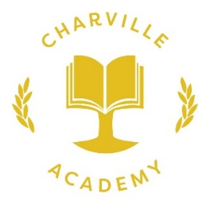

Performance Data 2018 - 2019

YEAR 1 Phonics Screening
Year 1: 83% passed
Year 2: Combined pass rate of 92%

