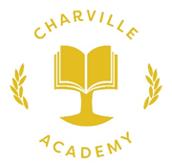
Phonics Data 2018

SUBJECT | % Charville who passed the Phonics Screening in 2018 | National 2018 pass %
Phonics | 89 | TBC

