

“Inspiring a love of lifelong learning”

Attendance Policy

Policy date: December 2025
Review date: September 2026

Learning at Charville is underpinned by our Core Values

Respect
Independence
Self-belief
Honesty
Caring
Determination

CONTENTS
Section | Item |  | Page Number
1 | Scope |  | 3
2 | Aim |  | 3
3 | Names Staff with a Responsibility for Attendance |  | 3
4 | Importance of Regular Attendance |  | 4
5 | Attendance Target |  | 7
6 | Absence |  | 7
7 | Punctuality |  | 8
8 | The 10 Session Threshold |  | 9
9 | Roles and Responsibilities |  | 9
 | 9.1 | Parents/Carers | 9
 | 9.2 | Pupils | 9
 | 9.3 | The School | 10
 | 9.4 | The Headteacher | 10
 | 9.5 | The Attendance Officer and Senior Leader Responsible for Attendance | 10
 | 9.6 | The Governing Board | 10
10 | School Procedures |  | 11
11 | Attendance Contracts and Attendance Panels |  | 11
 | 11.1 | Attendance Contracts | 11
 | 11.2 | Attendance Panels | 11
12 | Penalty Notices for Poor Attendance & Holiday taken during term time |  | 11
13 | Performance Licences |  | 13
14 | Children Missing from Education |  | 13
15 | Legislation |  | 13
16 | Policy Review |  | 14
17 | Equal Opportunities |  | 14
18 | Relevant Policies |  | 14
Appendices
1 | Attendance Road Map |  | 15
2 | Hillingdon Attendance Support Team Attendance Process Flowchart – Formal interventions that are to be held by the school |  | 16
3 | School Attendance Letters |  | 17

1. Scope

This Attendance Policy applies to all children in the school and is an overarching document which sets out how we will manage attendance.

2. Aim

Charville Academy is a values-based school and provides an environment which promotes the school values and prepares every child for lifelong learning opportunities. We believe that regular attendance at school is crucial in ensuring every pupil can reach their full potential. For our children to gain the greatest benefit from educational opportunities it is vital that they attend school regularly, and on time, every day the school is open unless the reason for absence is unavoidable. Good attendance helps to build good habits or reliability and timekeeping needed for future study and employment. We recognise how important it is to work in partnership with parents and carers to support every pupil to achieve this.

This policy is written with the children and their families in mind and underpins the school ethos to:
- Promote children’s welfare and safeguarding
- Ensure every pupil has access to the full-time education to which they are entitled
- Ensure that every pupil succeeds whilst at school
- Ensuring that pupils have the opportunity to access a wide range of opportunities through school activities
- Ensure that parents and carers are supported to ensure their child can attend school.

This policy has been developed in consultation with school governors, teachers, the local authority, pupils and parents/carers. It seeks to ensure that all parties involved in pupils’ school attendance are aware of and informed of attendance matters in school and to outline the school’s commitment to attendance. It details the responsibilities of individuals and groups involved and the procedures in place to promote and monitor pupil attendance.

The policy aims to raise and maintain levels of attendance by:
- Promoting a positive and welcoming atmosphere is which pupils feel safe, secure, valued and able to thrive
- Raising awareness of the importance of good attendance and punctuality
- Ensuring that attendance is monitored effectively, and decisive action is taken to support pupils
- Ensuring that school and families can work in partnership to support all pupils’ attendance.

3. Named Staff with a Responsibility for Attendance

Attendance forms part of the role and responsibility of all stakeholders. All stakeholders are expected to be a role model for good attendance and punctuality.

Alongside an individual’s class teacher, the following named staff members have responsibility for pupil attendance:

Attendance Officer | Mrs A Trotter
Attendance Lead (Senior Leader) | Miss L Innes
Headteacher | Mrs N Kelly
Governor with responsibility for attendance | Mrs S Gemmill

Contact details for attendance:
Telephone – Via the main office on 0208 845 1707 or 07367 291507
Email - attendance@charvilleacademy.org

All school staff are highly committed to working with parents/carers and pupils to ensure as high a level of attendance as possible which in turn optimises the attainment of our pupils.

4. Importance of Regular Attendance

Charville Academy is committed to maximising attendance rates and ensuring high levels of punctuality in order to ensure that all pupils are able to take the fullest advantage of the learning experiences available to them.

Any absence affects the pattern of a child’s learning and regular absence will negatively affect their learning; this also disrupts teaching routines potentially impacting on the learning of others in the class/year group. Ensuring regular attendance of a child at school is the legal responsibility of the parent/carer and permitting absence from school without a good reason creates an offence in law and may result in prosecution. Any loss of time at school can adversely affect a child’s attainment.

Creating and promoting a pattern of regular attendance is everyone’s responsibility – parents/carers, pupils and all members of school staff.

To help us all focus on this the school we will:
- Give your details on attendance in our regular newsletters
- Report to you on how your child is performing in school, what their attendance and punctuality rate is and how this relates to their attainment via parents evenings and the end of year school report
- Celebrate good attendance through weekly recognition in assembly
  - Issuing of house points in line with the Behaviour for Learning policy to individuals with attendance above 95%
  - Recognition of classes with attendance above 95%
- Reward individuals with attendance above 97% through individual termly certificates
- Recognise in assembly and reward through individual termly certificates individuals with 100% attendance
- Recognise those students that show a significant improvement over a period of time or via an agreed attendance contract through individual certificates
- Provide support to all parents and carers regarding the attendance of their child.

In line with the Department for Education (DfE)Working Together to Improve School attendance statutory guidance we offer a supportive, stepped attendance approach, as shown in our Attendance Roadmap.

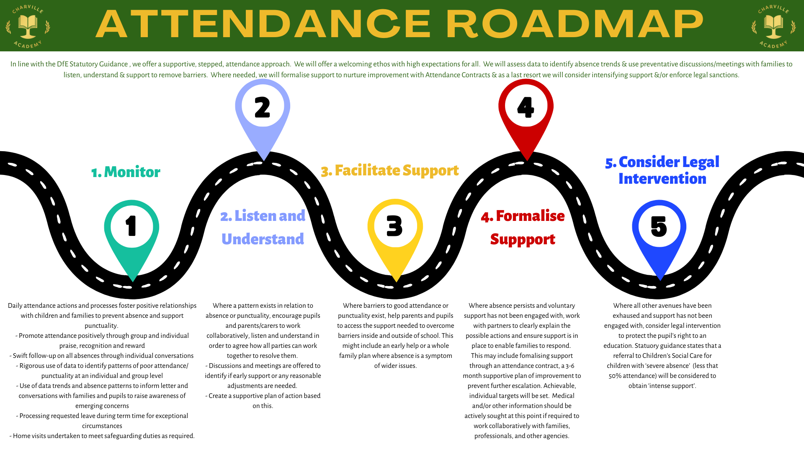
5. Attendance Target

The school attendance target is 97% and above and in order to improve attendance parents/carers and pupils have an important part to play in meeting this target. The minimum level of attendance for our school is 95% and we will update you on this regularly through the newsletter.

Throughout the school year we will monitor absences and punctuality to identify where improvements need to be made and the action we can all take to support this.

If allowed to remain unchecked, persistent absence and lateness will significantly impact on a pupil’s progress and achievement. Our parents/carers play a vital role in ensuring that this is achieved.

Attendance is a whole school area for improvement. It has a direct relationship with the attainment of individuals and groups of students and hence the standards achieved by the school.

6. Absence

Every half-day of absence from school have to be classified by the school, not by the parent/carer, as either AUTHORISED or UNAUTHORISED. For this reason, we will always request the reason for absence and discuss this with the parent/carer.

Authorised absences are mornings or afternoons away from school for a good reason and can include illness and medical appointments which unavoidably fall during school time.

Wherever possible we request parents and carers make medical or dental appointments outside of school hours. However, we recognise that this is not always possible and, in these circumstances, request that the pupil should be out of school for the minimum amount of time necessary – Pupils are expected to attend school before and after appointments. Parents/carers need to provide proof of medical appointments in advance. If it is an emergency appointment, please request an attendance card as proof.

Unauthorised absences are those which the school does not consider reasonable and for which no ‘leave’ has been given. This type of absence can lead to the Local Authority Attendance Support Team using sanctions and/or taking legal proceedings. This includes:
- Parents/carers keep children off school unnecessarily
- Absences which have not been properly explained
- Children who arrive too late to get a mark
- Day trips/activities and holidays in term time which have not been authorised
- Excessive illness without medical evidence.

Whilst children may be off school because they are ill, they may also be reluctant to attend school. If your child is reluctant to attend school, it is important that you contact the school so that we can work together to support your child and resolve any concerns. It is important that you do not allow absence or give into pressure to excuse them from attendance as this gives the impression that school attendance does not matter.

Parents/ carers must contact the school every day their child is absent by 9:00 am or as soon as practically possible on either 0208 845 1707 or 07367 291507. We will be able to discuss your child’s absence with you during this call.

You can support your child by:
- Ensuring regular and early bed times
- Helping with homework and reading
- Having uniform and equipment ready the night before
- Providing a healthy breakfast
- Reporting any academic or social concerns promptly
- Maintaining open and honest communication with the school
- Being positive about school and their learning
- Encouraging your child to develop their friendship circle.

The attendance register is a legal document and must be kept electronically. All schools/academies must take a register at the start of the morning session and again during the afternoon session.

Afternoon attendance registers are taken at:
Nursery - 12:30pm
Reception and KS1 - 1:00pm
KS2 - 1:30pm

The registers are marked using attendance codes mandated by the Department for Education (DfE). The headteacher reserves the right to exercise their final discretion on attendance codes based on the evidence provided.

7. Punctuality

Poor punctuality is also managed as attendance. Missing the start of the school day means that pupils may miss work or opportunities for additional support or 1:1 reading and do not get the opportunity to get vital information about the day from the teacher. Arriving late not only disrupts the learning of your child but also others within the class. It can also be embarrassing for the children; and can encourage further absence.

How we manage punctuality and lateness:
- The school learning day starts at 8:40am with gates and doors opening at 8:30am. Your child needs your support to be in class on time.
- The school gates will close at 8:40am and children arriving after this time must be brought, by an adult, to the main reception, where they need to be signed in
- In accordance with the regulations, if your child arrives after 8:40am, they will receive a late mark, however if they arrive after 9:10am they will receive a mark that shows them to be on site, but this will not count as a present mark and it will show they have an unauthorised late mark on the Attendance Register. This may mean you could face the possibility of a penalty notice if the problem persists
- If your child has a persistent late record, you will be asked to meet with a member of the Attendance or Senior Leadership Team (SLT) to resolve the problem. However, please be aware you can approach a member of the SLT or the Attendance Officer at any time if you are having problems getting your children to school on time

8. The 10 Session Threshold

The national threshold for absence is 10 unauthorised sessions in a rolling 10 school week period. Each school days is equivalent to 2 sessions – AM and PM. This threshold is set by the Department for Education. The rolling 10 school week period can span across different terms or school years.

Examples of how absence could meet the threshold include:
- 5 days of unauthorised absence in one block
- 3 days of unauthorised absence before the summer holidays and 2 days unauthorised absence on return in September
- 3 days of unauthorised absence before the summer holidays and 4 lates after the register closes in September
- 4 days of unauthorised absence and 2 lates after the register closes
- 4 sessions of unauthorised absence and 6 lates after the register closes
- 10 lates after the register closes

All of these examples equal 10 sessions of unauthorised absence and meet the threshold at which the school is required to consider taking action.

9. Roles and Responsibilities

9.1 Parents/Carers

- To ensure the regular attendance and good punctuality of their child
- To ensure a good attitude to attendance and punctuality
- Communicate to the school any issues which may be affecting their child’s attendance or punctuality and discuss what can be improved
- Engage with school staff in discussions around the absence of their child and work in partnership
- To ensure pupils go to bed at a regular time and have enough sleep to be ready to learn
- In Reception to Year 6: ensure their child arrives at school from 8:30am and is in class for registration to be taken at 8:40am
- In Nursery:
  - 30 hours: ensure their child arrives at school at 9:00am
  - AM: ensure their child arrives at school between 8:30am and 8:40am
  - PM: ensure their child arrives at school between 12:15pm and 12.30pm
- To contact the school every day their child is absent, giving a legitimate reason for absence by 9:00am.

9.2 Pupils

- Have a good attitude to attendance and punctuality
- Communicate with parents and the school about any worries or anxieties that may affect attendance
- Go to bed at an appropriate time and come to school on time and ready to learn.

9.3 The School

- To provide support for children and families to overcome barriers to good attendance and punctuality, including support from learning mentors, welfare officer, attendance officer and/or referral to other agencies
- To educate parents/ carers and pupils on the importance of good attendance and punctuality
- To keep accurate and up to date records on punctuality and attendance
- To follow current government guidance regarding the monitoring and recording of attendance
- To communicate with parents/ carers regarding attendance and punctuality concerns
- Contact parents/carers if no message has been received regarding absence
- Make follow up contact with the parent/carer if a pupil is absent
- To liaise with the Local Authority Attendance Support Team regarding ongoing concerns over children’s attendance
- To liaise with other professionals involved in working with a pupil or make referrals where required.

9.4 The Headteacher

- To ensure this policy is implemented consistently across the school
- Monitor school-level attendance data and report it to the Governing Board
- Assign a senior leader to work alongside the Attendance Officer to track and monitor attendance at a school and individual level
- Make referrals to the Attendance Support Team where necessary.

9.5 The Attendance Officer and Senior Leader Responsible for Attendance

- Will work in partnership with all parents and carers
- Monitor attendance data at school and individual pupil level
- Review attendance data to identify actions for prevention of poor attendance through good whole school attendance management, early intervention to reduce absence before it becomes habitual and targeted support to reengage persistently and severely absent pupils
- Report concerns about attendance to the headteacher
- Arrange calls and hold meetings with parents regarding attendance and punctuality concerns
- Work with the Attendance Support Team to tackle persistent absence and severe absence
- Share attendance data with the Virtual School for pupils with a social worker
- Advise the Headteacher of/make referrals to the Attendance Support Team.

9.6 Governing Board

- Recognise the importance of school attendance and promote it across the school’s ethos and policies
- Ensure school leaders fulfil expectations and statutory duties
- Regularly review attendance data, discussing and challenging trends, and helping school leaders focus improvement efforts on the individual pupils or cohort who need it most
- Ensure school staff receive adequate training on attendance.

10. School Procedures

If a pupil is absent and parents/carers have not made contact with the school this will always be followed up on the day as it is part of our duty of care to safeguard all pupils from harm. We will:

- Initially text the parent/carers
- Follow up with a phone call if no contact is received
- If no response is received by the second day staff will visit the home that day (where a pupil/family is considered by the senior leadership team to be vulnerable this will be on the first day of absence)
- If no contact is made on the second day of absence contact the Attendance Support Team for advice.

If a pupil is absent from school, and evidence of the absence has not been received in advance, the attendance officer will make a follow up call to the parent or carer to discuss the absence. If no response is received, and the senior leadership team are concerned about a pupil/family or the reason for absence, a home visit may be undertaken.

11. Attendance Contracts and Attendance Panel

Charville Academy follows the local authority Attendance Support Team guidance for attendance contracts and attendance panels

11.1 Attendance Contracts

- To work in partnership with the parent/carers
- Formal written agreement between the parent/carer and either the school or local authority to address irregular attendance at school or alternative provision
- Parent/carers can be requested to enter an attendance contract.

11.2 Attendance Panel

- A formal intervention
- Takes place when a parent/carer has failed twice to attend an organised meeting to discuss attendance and an attendance contract was to be offered
- The attendance panel agreement is held in the parent/carers absence and agreed by the attendance officer and responsible senior leader.

12. Penalty Notices for Poor Attendance & Holidays taken during term time

The school will make every attempt to contact the parent/carer by telephone and in writing. In the first instance we would invite them to discuss attendance unless the absence relates to leave in term time without permission. Where all other avenues have been exhausted and support is not working or not being engaged with, attendance may have to be enforced where necessary through statutory intervention or prosecution to protect the pupil’s right to an education. A referral may have to be made to the Local Authority under the following circumstances based on the national framework for penalty notices.

A single consistent national threshold for when a penalty notice must be considered of ten sessions (usually equivalent to five school days) of unauthorised absence within a rolling ten school week period. This may span different terms or school years. This will include unauthorised absence for lateness Code U.

We recognise that there may be very exceptional circumstances, which may result in a pupil being unable to attend school. Please note that family holidays cannot be an exceptional circumstance, irrespective of the child’s overall attendance.

All requests for exceptional circumstance leave must be put in writing to the headteacher. This letter must contain: The reason for the request, the dates of absence, including the return date, evidence relating to the reason for booking and details of any bookings made. Examples of the type of evidence required may include evidence of the date of a flight booking, evidence of family illness or bereavement, evidence of a wedding or evidence of participation in a sporting/performance event. Where circumstances are considered to be exceptional the school may choose to only authorise some of the days requested. All decisions will be discussed with the applicant.

Where a parent removes a child when the application for leave was refused or where no application was made to the school, the issue of a penalty notice may be requested by this school. The fundamental principles for defining ‘exceptional’ are events that are “rare, significant, unavoidable and short”. By 'unavoidable' we mean an event that could not reasonably be scheduled at another time.

- A term time holiday taken without permission would count towards the ten sessions
- A national limit of two penalty notices that can be issued to a parent for the same child within a rolling 3-year period. At the third (or subsequent) offence(s) other legal prosecution will be considered

Penalty notices are issued to each parent or carer for each of their children for example two parents with three children would receive a total of six penalty notices, one parent with two children will receive a total of two penalty notices. This also applies to a parent/carer who does not live with the child.

From September 2024 each penalty notice is £80 if paid in the first 21 days, from days 22 to 28 the fine doubles to £160 for each penalty notice.

For the second offence issued to the same parent for the same child within a rolling 3-year period will be charged at a higher rate of £160 for days 1 – 28, with no option for this second offence to be discharged at the lower rate of £80.

If a penalty notice is not paid or the Attendance Support Team assesses that that the level of absence warrants court action, the local authority will arrange for a court hearing. There are a range of sentencing options available to the magistrate including the maximum penalty of a fine of up to £2500 per parent for each offence as well as the possibility of up to three months in prison.

13. Performance Licences

The applicant for a performance license (usually the production company or theatrical agent) is obliged to seek the view of the school when applying for an absence request. Leave requests for performance licenses will be considered by the Head Teacher on an individual basis when the child’s attendance for the year is above 95% and they are making expected levels of progress. A request may be declined if either of these thresholds is not met, or if the timing of the absence could be detrimental to the child’s education.

14. Children Missing from Education
In Children Missing in Education – Statutory Guidance for Local Authorities and Schools, children missing education are defined as those who are not on a school roll or receiving suitable education otherwise than at school. Those who are regularly absent or have missed 10 school days or more without permission may be at risk of becoming 'children missing education'.

There will not always be a safeguarding concern for children who are missing education. Most children are moving schools supported by their parents/carers, schools and local authority admissions services. A smaller number, however, are at risk of dropping out or disengaging from education and being out of school, they are at risk of exploitation, going missing and significant harm.

In the circumstances of a child going missing who is not known to any other agencies, the Headteacher should inform the Children Missing Education (CME) Officer of any child who has not attended for 10 consecutive school days without provision of reasonable explanation which can result in the child being removed from the school roll. Prior to doing so, the school will have made enquiries to ascertain whether the child is still residing at the home address and is not attending or whether the child is missing.

15. Legislation

This policy meets the requirements of the school attendance guidance from the Department for Education (DfE). We work with the Local Authority Attendance Support Team to enforce the legal frameworks as defined in the ‘The 1996 Education Act’ and the Children’s Act. In line with government mandates attendance data is shared with the government.

This document should be read in collaboration with the DFE publications below:
- Working together to improve school attendance
- Summary table of responsibilities for school attendance.

16. Policy Review

This policy will be reviewed annually by the Governing Board to ensure it is up to date with current legislation, statutory guidance and best practice.

17. Equal Opportunities

At Charville Academy we recognise the importance of ensuring children are supported to ensure they attend school regularly and access the same opportunities as their peers. This policy should be read in conjunction with the Equalities Policy.

18. Relevant Policies
- Child Protection Policy
- Safeguarding Policy
- Special Medical Needs Policy
- Equalities Policy
- Behaviour for Learning Policy.

Written by: Louise Innes, Attendance Lead
Approved by: FGB
Date approved: December 2025
Review Date: September 2026

Appendix 1 – Attendance Road Map
Appendix 2 – Hillingdon Attendance Support Team Attendance Process Flowchart – Formal interventions that are to be held by the school (This document is adopted directly from Hillingdon Local Authority)

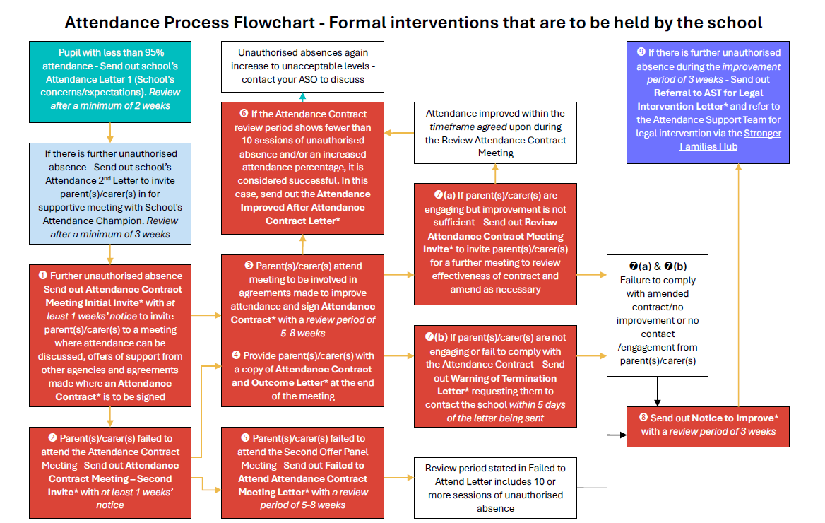

Appendix 3 – School Attendance Letters

Note - All letters are examples and can be adapted to suit the circumstances relating to individual pupil attendance

Letter 1 – Concerns about a pupil's high level of absence
Use this letter in situations where a pupil’s absence has been authorised, but absence levels are high. For example:
- A pupil is regularly ill, but doesn't have an identified medical need
- Combined circumstances (such as a family bereavement and pupil illness) means the pupil has missed a lot of lesson time

Dear [insert name of parent/carer],

We hope this message finds you well. We are writing to you because we have noticed that [pupil name] has missed a significant amount of school recently. We understand that every family’s situation is unique, and we want to work with you to make sure [pupil name] is able to succeed at school.

Why we are contacting you:
- [Pupil name] has missed [insert number of days] in the last 10 school weeks, meaning they have missed out on [insert absence as a percentage] of learning time this [term/year]
- We are concerned that these absences may mean [pupil name] is missing out on key parts of their education and may risk falling behind with their learning.

How we can work together:
We want to support both you and [pupil name] in any way we can, and to understand if there is anything further happening at home or at school that may be making attendance difficult. Together, we can:
- Identify any additional support [pupil name] might need
- Explore ways to help [pupil name] catch up on school they’ve missed
- Discuss any temporary or ongoing circumstances affecting attendance.

Next steps:
- Please contact the school office on 0208 845 1707 at your earliest convenience so we can arrange a time to talk
- If you prefer, you can reply to this letter with any information you’d like to share before our conversation.

We want to work collaboratively with you to help [pupil name] overcome any barriers to regular attendance and make sure they feel supported and confident at school.

Thank you for your understanding and co-operation.

Yours sincerely,
[Name]
Headteacher
Letter 1 – Concerns about a pupil's unauthorised absence

Dear [insert name of parent/carer],

We are writing to you because we have noticed that [pupil name] has recently taken an unauthorised [absence/absences] from school.

Details of absence
[Name] has been absent from school for a total of [number] days on the following dates:
- [date]
- [date]
This means they have missed out on [insert absence as a percentage] of learning time this [term/year].

Why regular attendance matters
We want to work together with you to ensure [name] is able to:
- Fully engage in their learning and make good academic progress
- Develop friendships and feel part of the school community
- Build routines and confidence that will help both now, and in the future.

How we can support you
We understand that every family’s circumstances are unique, and there may be challenges at home or school that make attendance difficult. However, we’re here to help. Please let us know if:
- There is anything happening at home or at school that’s affecting [name]’s attendance
- You need support with helping [name] attend regularly
- There are gaps in [name]’s learning we can help to address.

Next steps
- Please contact the school office on 0208 845 1707 as soon as possible, so we can arrange a time to discuss these absences
- We will work together to understand any challenges and agree on how we can help [name] catch up on any missed schoolwork.

Important information about unauthorised absence
We want to be open about the school’s responsibilities. Please note:
- Unauthorised absences can result in a penalty notice being issued if your child has 10 sessions of unauthorised absence in a rolling period of 10 school weeks (10 sessions is equivalent to 5 days)
- More information about penalty notices and the attendance policy are available on our school website [www.charvilleacademy.org], or from the school office.

We are committed to working with you and [name] to support their learning and wellbeing.

Please do get in touch so we can move forward together.
Yours sincerely,
[Name]
Headteacher

Letter 1 – Concern about punctuality

Dear [insert name of parent/carer],

Concern about [pupil name]’s punctuality

We are writing to you because [pupil name] has been late to school [number] times in the last 10 school weeks. We know that mornings can sometimes be challenging, and we want to work together with you to support [name] in arriving on time each day.

Details of lateness:
- Arrived after the register closed:
  - [date]
  - [date]
- Arrived late (before register closed):
  - [date]
  - [date]

Our school day starts promptly at 8:40, and registration closes at 9:10.

Arriving on time each day is important because it:
- Ensures your child doesn’t miss out on essential learning
- Reduces disruption for teachers and classmates
- Helps your child settle into the school routine.

We understand that there may be things happening at home or at school that are making punctuality difficult. Our aim is to work in partnership with you to find solutions. However, it is important to be aware that persistent lateness can result in a penalty notice if your child arrives after the register closes 10 times within 10 weeks.

Next steps:
We would like to invite you to a meeting to discuss how we can support [name] together. In this meeting, we hope to find out whether there is:
- Anything happening at school that makes it difficult for [name] to arrive on time
- Anything happening at home that we can help with, or that you think we should be aware of
- Anything we can do to make it easier for [name] to be on time for school.

Please contact the school office on 0208 845 1707 to arrange a suitable time for this meeting.

If you need help with evening and morning routines, or any other aspect, please let us know in advance so we can make sure the right support is available.

We appreciate your support in making sure [name] gets the most out of their school day. If you have any questions before the meeting, please do not hesitate to contact us.

Yours sincerely,
[Name]
Headteacher

Letter 2 – Invite parents/carers in to discuss attendance

Dear [insert name of parent/carer],

Invitation to discuss [name]’s school attendance

Following my previous letter sent on [enter date] we are disappointed that despite our offer to discuss support there has been no significant improvement in [name]’s attendance/punctuality.
Our records show that [name]’s current attendance is ** %.

It is important that children attend school regularly and on time. Here at Charville Academy, our best interests are to ensure our pupils reach their full potential with can only be done when pupils attend school regularly. Once again. we are giving you the opportunity to discuss any issues you may be facing with getting your child[ren] into school. We would like to understand the challenges that are preventing [name] attending school regularly and/or on time.

We would like to invite you to come in to have a discussion about [name]’s attendance at school. Our aim is to understand and address any barriers together, and to make sure [name] is fully supported in attending school regularly.

During the meeting, we would like to talk about:
- Whether there is anything happening at school that makes it difficult for [name] to attend
- Whether there are any challenges at home that we could help with, or that you would like us to be aware of
- Anything we can do to support you or make it easier for [name] to attend school regularly.

Next steps
- We are offering a meeting with [name] our [role] on [date and time]. Please contact the school office on 0208 845 1707 to confirm your attendance or if you cannot attend to agree a mutually convenient time for this discussion
- We will work together to understand any challenges and put support in place
- If you need any assistance (such as translation services or accessibility support), please let us know when you get in touch
- If you are unable to attend in person, we can arrange a phone or video call.

Important information about unauthorised absence
We want to be open about the school’s responsibilities. Please note:
- Unauthorised absences can result in a penalty notice being issued if your child has 10 sessions of unauthorised absence in a rolling period of 10 school weeks (10 sessions is equivalent to 5 days)
- Please note, you may be asked for medical evidence for futures absences in order for them to be authorised
- More information about penalty notices and the attendance policy are available on our school website www.charvilleacademy.org, or from the school office.

We are here to support you and [name], and we hope to work together to find the best way forward.

Thank you for your attention to this important matter.

Yours sincerely,
[Name]
Headteacher

Letter – Congratulations for improving attendance

Congratulations on improved attendance!

Dear [insert name of parent/carer],

We are absolutely delighted to celebrate [name]’s fantastic achievement in improving their school attendance!

Since [date], [name]’s attendance rate has increased from [percentage]% to [percentage]% – this means [number] additional days of valuable learning and experiences at school. This is a significant accomplishment and a testament to [name]’s commitment and your ongoing support at home.

Why this matters:
Regular attendance makes a real difference to children’s progress, friendships and confidence. By being in school more often, [name] is giving themselves the best chance to succeed and enjoy everything our school has to offer.

A big thank you for encouraging and supporting [name] to attend regularly – your partnership is so important.

Celebrating success:
To recognise [name]’s hard work and improvement, [he/she/they] will be:
- Receiving a certificate of recognition
- Receiving a house point.

Next steps:
We encourage [name] to keep up this fantastic effort! If you need any further support or have questions about attendance, please don’t hesitate to contact us on 0208 845 1707.

Once again, congratulations to [name] and your family on this wonderful achievement.

Yours sincerely,
[Name]
Headteacher

Other Letters

The following letters will follow the local authority template letters:
- Attendance Contract Meeting – Initial invite attendance concerns
- Attendance Contract Meeting – 2nd attempt invite
- Attendance Contract – Outcome Letter
- Attendance Contract Meeting – Failed to attend
- Attendance Contract Meeting – Attendance improved
- Attendance Contract Review Meeting
- Warning of Termination Letter
- Notice to Improve
- Referral to Attendance Support Team for legal intervention

