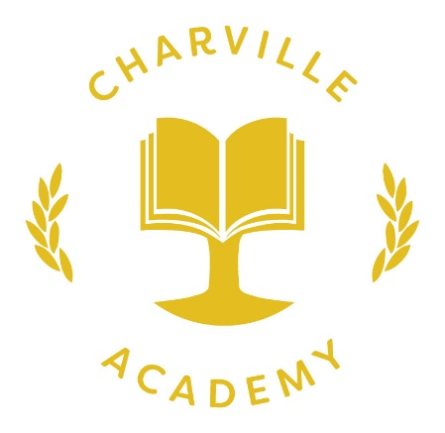

“Inspiring a love of lifelong learning”

Asthma Policy

Policy date: November 2023
Review date: November 2026

Learning at Charville is underpinned by our Core Values, which are as follows:
Respect
Independence
Self-belief
Honesty
Caring
Determination

Contents
Section | Contents | Page
1. | Scope | 3
2. | Aim | 3
3. | Medications and Inhalers | 3
4. | Administering Medication | 3
5. | Parental Responsibilities | 4
6. | Emergency Inhalers | 4
7. | Advice and Support | 5
8. | Adults with Asthma | 5
9. | Equal Opportunities | 5
10. | Related Policies | 5
Appendices
1 | Inhaler Usage Poster | 6
2 | Consent Form – Prescribed Asthma Inhaler & Use of Emergency Salbutamol Inhaler | 7

1. Scope

Asthma is a condition which affects a range of individuals including pupils, staff and volunteers across the Academy to different extents. Appropriate care is essential to ensure the health and safety of all those diagnosed with asthma.

2. Aim:
This policy contains the guidance and procedures to be followed when caring for pupils with asthma to ensure:
- Full participation in all aspects of school life and reduced absence
- Staff have a clear understanding of the procedures to follow in the event of a child having an asthma attack
- To ensure immediate access to inhalers
- To keep accurate records of children’s medication
- Adherence to the current guidance on use of emergency salbutamol inhalers in schools.

This policy also contains guidance for adults with asthma.

3. Medications and inhalers

There are two types of treatment both of which come in an inhaler.

Preventers - These inhalers are taken daily to make the airways less sensitive to individual asthma triggers. They are usually taken morning and night. They usually come in brown containers. These inhalers are not used or kept in school.

Relievers - These inhalers quickly open up the narrowed airways and help the individuals breathing difficulties. They usually come in blue containers. Children’s inhalers are stored in asthma boxes in the classroom. Adults are responsible for storage of their own inhalers.

All inhalers should be taken through a a spacer, into which the aerosol is released.

Every pupil diagnosed with asthma should have one prescribed reliever inhaler and spacer in school before the pupil begins attending. This is kept in the classroom. It is essential that all pupils with asthma are allowed to access their reliever inhaler freely at all times.

In classroom reliever inhalers are kept in boxes. Each inhaler is labelled with the child’s name. If the inhaler is used this should be recorded on CPOMS and the Welfare room must be advised. Inhaler boxes should be taken to all activities the children participate in.

Staff in Breakfast Club would use the nearest emergency pack.

4. Administering Medication

Every pupil is encouraged to administer their inhaler without any help under the supervision of an adult.

Some pupils need to use their reliever inhalers before exercise. Class teachers and the PE teacher are informed, the inhaler is administered and administration is recorded on CPOMS.

A member of staff will monitor the child while they take their inhaler and log on CPOMS.

Staff receive asthma advice on a yearly basis from the School Nurse. Asthma posters are in every asthma box and displayed around the school. These are updated yearly if required.

Parents/carers will be advised by a message via Arbor whenever their child uses their inhaler.

5. Parental responsibilities

Parents are responsible for providing the school with one prescribed inhaler and a spacer for their child.

It is the parent’s responsibility to replace any out of date medication as soon as they are notified of its expiry.

Parents are also required to keep the school informed about any changes in their child’s asthma or care plan.

Every parent signs a parental consent form giving permission for the reliever inhaler to be used and an emergency salbutamol inhaler administered, if necessary.

6. Emergency Inhalers

Emergency Salbutamol inhalers will provide medication in an emergency only for:
- Pupils who have been prescribed a salbutamol reliever inhaler and have written parent/carer consent
- Adults who have been prescribed a salbutamol reliever inhaler.

Emergency inhalers are kept in: Nursery, Welfare, EYFS (Fridge)), Staffroom and the Dining Hall.

Each pack contains:
- 2 x Inhaler
- 2 x Spacer
- List of pupils with consent.

In the event of an emergency, and the child’s own inhaler not being available/usable, staff should use the nearest emergency pack. When an emergency asthma pack is used Welfare must be notified immediately. They will then remove and replace the spacer.

7. Advice and Support

If further help is required with regards to the management of a pupil’s asthma to prevent it impacting on access to education advice should be sought from the School Nurse via Welfare.

Inhaler usage is shared with Hillingdon Hospital on a monthly basis to support health service with identifying children whose asthma requires review.

8. Adults with Asthma

Adults with asthma are responsible for ensuring they have access to a prescribed inhaler and spacer whilst on the school site.

Adults with asthma should be aware of any triggers for their asthma and ensure appropriate actions are taken to mitigate any risks. Where a particular risk is identified adults should ensure the Welfare officer is aware of this.

Is advised that adults with asthma declare this on their medical form and give it to the welfare officer.

9. Equal Opportunities

At Charville Academy we recognise the need to ensure individuals with asthma have equal opportunities across all school-based activities.

10. Related Policies

- Special Medical Needs Policy
- First Aid Policy

Written by: Louise Innes, Inclusion Manager

Approved by: FGB

Date approved: November 2023

Review Date: November 2026

Appendix 1 – Inhaler Usage Poster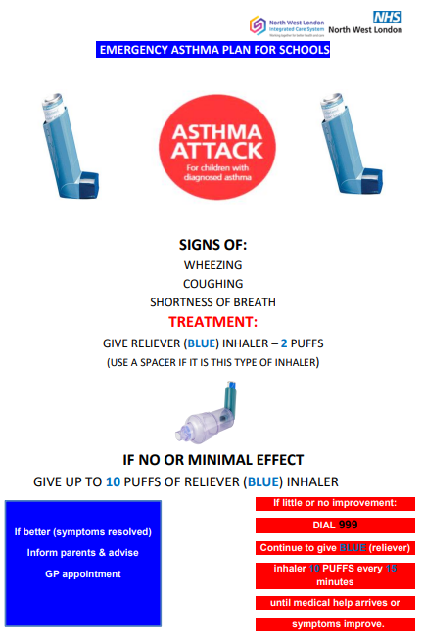

Appendix 2 Charville Academy


Consent Form - Prescribed Asthma Inhaler & Use of Emergency Salbutamol Inhaler

Child’s Full Name:

Child’s DOB:
I ............................................................................. (parent/guardian)
- Confirm that my child has been diagnosed with asthma / has been prescribed an inhaler [delete as appropriate] and consent to its use in school.
- Will ensure that:
  - my child has a prescribed, working, in-date inhaler to be kept in the classroom
  - my child is provided with an age appropriate spacer
- In the event of my child displaying symptoms of asthma, and if their inhaler is not available or is unusable, I consent for my child to receive salbutamol from an emergency inhaler held by the school for such emergencies.
Signed: | (Parent/Guardian)

Date:

