Year 5
 | Autumn 1  Victorians | Autumn 2  Victorians | Spring 1  South Asian History |  | Spring 2  Civil Rights | Summer 1  Space | Summer 2  Space
History | Queen Victoria  Industrial Revolution  Inventions and developments | British Empire  Florence Nightingale  Mary Seacole  Victorian  Christmas | Decolonisation of India  Gandhi  Partitioning of India and Pakistan |  | Transatlantic Slave Trade- Harriet Tubman  Civil Rights Movement  Rosa Parks  Martin Luther King Jnr  Malcolm X  Bristol Bus Boycott | Firsts in space The Space Race  J.F.K | NASA mathematicians (Hidden figures)
Geography | Local Geography Fieldwork |  |  | Mapping South Asia | Mapping the World  Mapping the British Empire | North America  Types of Biome-  Grasslands  Taiga  Temperate Deciduous | USA
Art | Wallpaper- William Morris  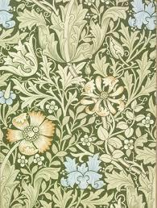 | Jerry Barret- The Mission of Mercy: Florence Nightingale receiving the wounded at Scutari  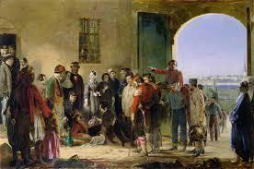  Vincent Van Gogh- Dutch shoes and chair  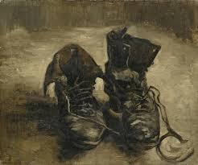  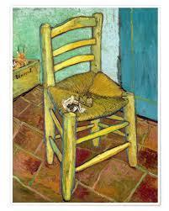 | 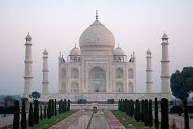  Architecture- Taj Mahal  Amrita Sher-Gill  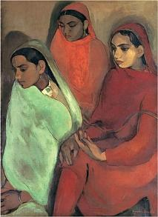 |  | Elizabeth Catlett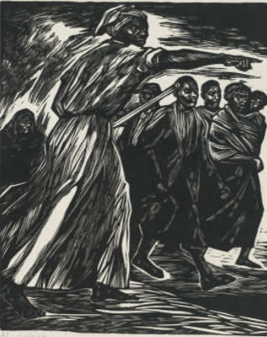 | Robert McCall: A Journey into Space  A Journey into Space  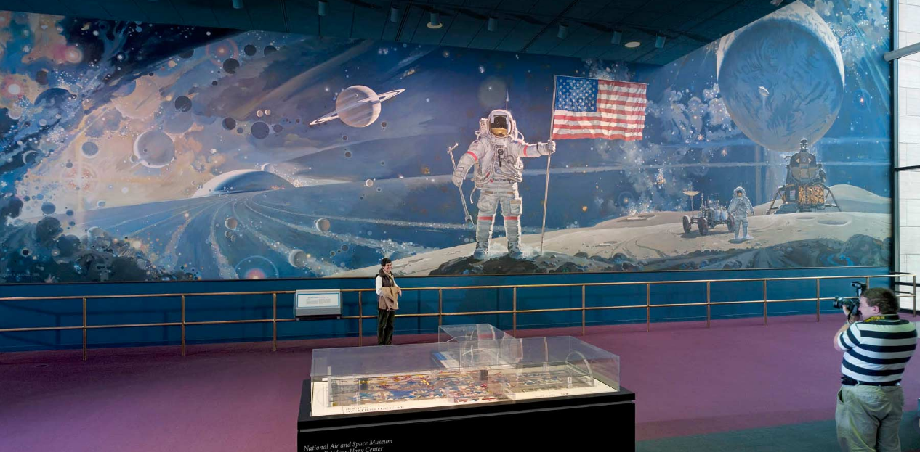 | Peter Thorpe- space art  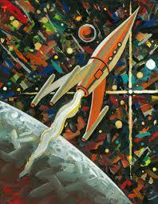  Alma Thomas  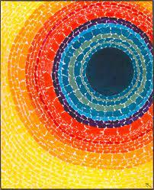
Science | Chemistry: Properties and Changes of Materials  Scientist/Inventor: Antoine Lavoisier |  | Biology: Living things and their habitats  Scientist/Inventor: Eva Crane |  | Biology: Animals including Humans | Earth Science and Physics: Earth and Space  Scientist/Inventor: Galileo  Neil deGrasse Tyson Mae C. Jemison Katherine Johnson | Forces  Scientist/Inventor: Albert Einstein  Stephen Hawking
D.T |  | Shell structures: Cardboard chairs | Food tech: Naan Bread |  |  | Electric motorised cars: Moon Buggy
PSHCE | Feeling Positive | Activism | Equal Opportunities and Unconscious Bias |  | Economic Wellbeing:  Managing Money | 5 Ways to Wellbeing  Giving | Life Changes  Relationships
R.E | Belief in Action Diwali Christmas  (Christianity) |  | Beliefs and Moral Values Easter  (Sikhism) (Christianity)  I |  |  | Prayer and Worship  (Sikhism) Beliefs and Practices  ( Christianity)
Computing | General skills – saving, opening files, logging in, accessing google classroom, creating folders, printing, downloading media, resizing images, moving images, layers of images, snipping an image, rotating an image  Online Safety:  SMART rules, Online images and fake news | Coding | Word processing - basic punctuation, finger spaces (space bar) (using shift and caps lock for capital letters), identifying spelling mistakes (using the error lines), backspace to delete, copy and paste, undo icon, changing font size and colour, inserting pictures, more complex punctuation, paragraphs, text alignment, bold, italic, underlining, thesaurus, manual spell check, inserting tables, adding rows and columns, touch-typing (2type) (25 words per minute)  Data Handling- Data logging (excel) |  |  | Game Creator (2DIY 3D) | 3D Modelling (2Design and Make)
P.H.E | Invasion Games | Striking and Fielding Games | Dance |  | Gymnastics | Net and Wall  Games | Athletics
Music | Romantic & Modern Music  Percussion & Keyboard | Christmas Concert | Indian Music &  Keyboard Level 2 |  | Activism, Protest Songs and Influential Musicians  Keyboard Level 2 | Space  The Planets / Bowie  Elton John  Keyboard Level 2 | Musicals  The Sound of Music
Key Text | Mister Creecher  Character Description  Oliver Twist  Street Child  Persuasive Argument | Treasure Island  Character Description  Treasure Island  Newspaper Article | A Beautiful Lie  Story Writing  Cinnamon  Story Writing |  | Brown Girl Dreaming  Poetry Writing | Hidden Figures  Biography Writing  Curiosity  Explanation Writing | Charlie and the Great Glass Elevator  Persuasive Advert  The Iron Man  Story Writing
Trips/Visits |  | Local area visit | Workshop |  |  | Science Museum

