Year 4
 | Autumn 1  Tudors | Autumn 2  Tudors | Spring 1  Modern Greece | Spring 2  Ancient Greece | Summer 1  Ancient Africa | Summer 2  Modern Africa
History | Mary Rose  Henry VIII and his wives  Dissolution of the Monasteries | Elizabeth I  Golden Age  The Spanish Armada | Heathrow Airport | Ancient Greek mythology  Olympics  Word origins  Democracy and law | Kingdom of Benin c. AD 900-1300 | South African Apartheid  Nelson Mandela
Geography |  | Transportation and trade | Greece- tourism  Coasts |  | The continent of Africa | Types of biome- Savanna and desert
Art | Portraits of Elizabeth I- Marcus Gheeraerts  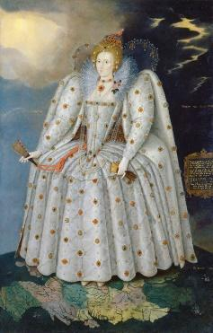 | Impressionism  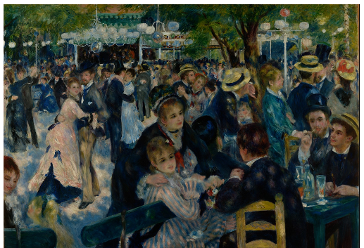 | Zaha Hadid- amazed by architecture  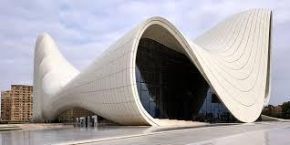  Ken Yeang - Ecological designer of buildings  Anne Vallayer-Coster- Attributes of Music (Science)  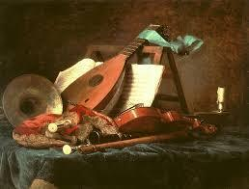 | Architecture of the Parthenon – Pheidias and assistants  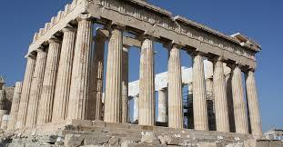  Myths and Legends- Peter Paul Rubens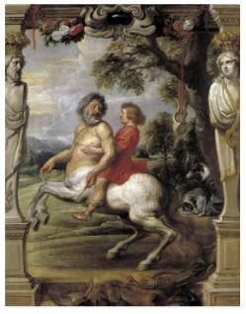 | Richard Kimbo- cultural tradition  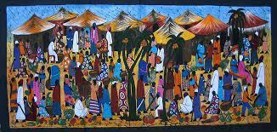  Joseph Amedokpo- cultural tradition  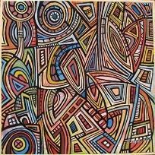  Adam Traore | Vincent Van Gogh- Sunflowers  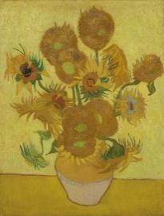  Anselm Kiefer- The Order of the Night  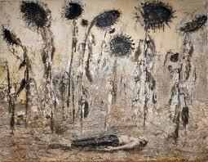  Sunflower seeds- Ai Weiwei  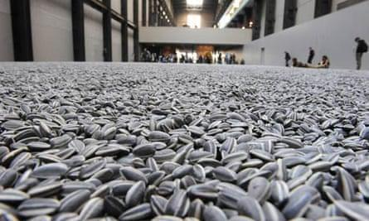
Science | Physics: Forces Magnets & Buoyancy  Scientist/Inventor: Issac Newton | Physics: Electricity  Scientist/Inventor: Thomas Edison  Ronit Kanwar | Physics: Sound  Scientist/Inventor: Alexander Graham Bell | Chemistry: States of Matter  Scientist/Inventor: David Tabor | Biology: Animals including Humans  Scientist/Inventor: Alexander Fleming | Biology: Living things and their habitats  Scientist/Inventor: Jane Goodall  Dian Fossey
D.T | Frame Structures: Tudor roofs | Paper Circuits: Christmas cards | Arch Structures: Greenhouses |  | Food tech: Couscous
PSHCE | Overcoming Negative Feelings | Leaders and Gender Stereotypes | Risks and Dangers | Puberty | 5 Ways to Wellbeing  Climate Change | Living in a Diverse World
R.E | Buddha’s  Teaching Diwali Christmas  (Christianity)  (Buddhism) |  | The 8-Fold Path Easter  (Christianity)  (Buddhism) |  | How does the Qur’an  influence Muslims  today? Prayer and Worship  (Christianity)  (Islam)
Computing | General skills – saving, opening files, logging in, accessing google classroom, creating folders, printing, downloading media, resizing images, moving images, layers of images, snipping an image, rotating an image  Online Safety- SMART rules, Social media, age restrictions | Animation | Word processing - basic punctuation, finger spaces (space bar) (using shift and caps lock for capital letters), identifying spelling mistakes (using the error lines), backspace to delete, copy and paste, undo icon, changing font size and colour, inserting pictures, more complex punctuation, paragraphs, text alignment, bold, italic, underlining, thesaurus, manual spell check, inserting tables, adding rows and columns, touch-typing (2type) (20 words per minute)  Data Handling: bar charts (excel), branching/flowcharts (2classify) |  | Coding | Logo
P.H.E | Invasion Games | Striking and Fielding Games | Dance | Gymnastics | Net and Wall  Games | Athletics
Music | Notation & Harmony  Percussion & Keyboard | Christmas Concert | Baroque & Classical  Keyboard Level 1 | Film Music  & Soundtracks  Keyboard Level 1 | The evolution of African Music  Intro to Djembe | Musicals  Singing In The Rain
Key Text | Spymaster  Story Writing  Spymaster  Newspaper Writing | Diver’s Daughter  Letter Writing  Diver’s Daughter  My Story Lady Jane Grey  Biography Writing | Who Let The God’s Out  Character Description  The Odyssey  Story Writing | Greek Myths  Newspaper Writing  Persuasive Leaflet | Journey to Jo’Burg  All Aboard the Bobo Road  Letter Writing  The Fire Children  Poetry Writing | Children of the Benin Kingdom  Report Writing  Nelson Mandela Long Walk to Freedom  Persuasive Speech
Trips/Visits |  | Hampton Court Palace | Coast trip |  |  | The National Gallery and British Museum

